Performance analysis of the “competitor’s site”

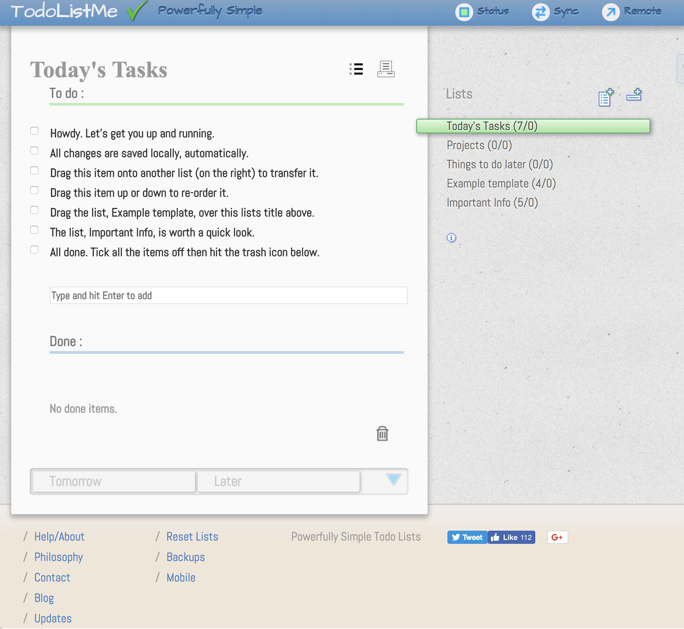

Not part of the analysis, but noteworthy is that the site is not responsive. According to a study of Gartner Group about 80% of the internet content is accessed by mobile devices like mobile phones, smartphones and tablets.

Our site is responsive.

With this being said, let's have a look at the performance.

## 1. Loading behaviour

Our site loading behaviour:

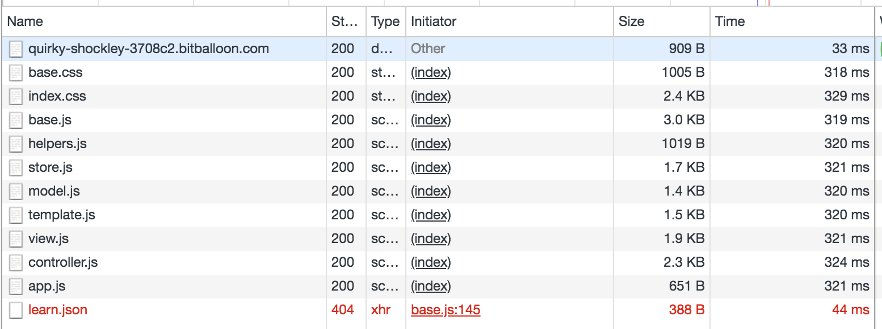

I am not sure why, but it tries to load learn.json, that is not present in the project.

The most time-consuming calls of the competitor site:

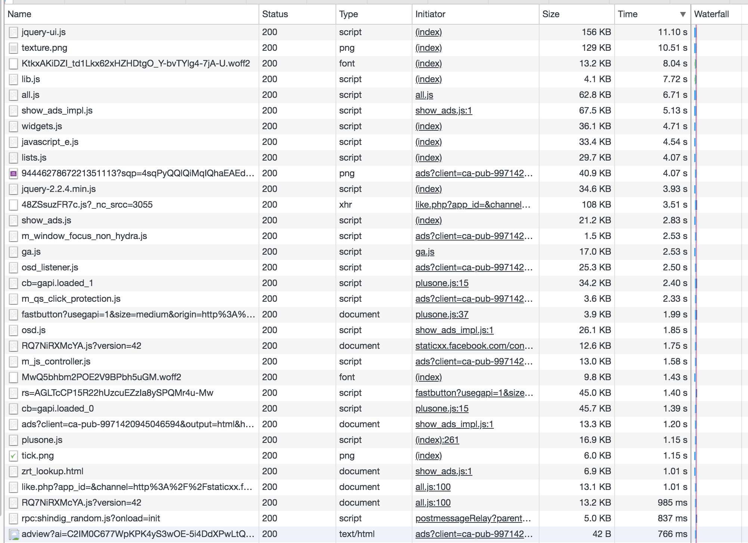

A disadvantage over our site is the tremendous loading time on slow networks. See the screenshot of the loading behaviour. That site uses among other libraries like jquery(3.93 s), jquery-ui (11.10 s), Facebook(1.75 s), and resources like the background image (10.51 s).

Normally the numbers do not look so bad, because of the cut tremendously by using the cache of the browser.

## 2. Runtime performance by Task

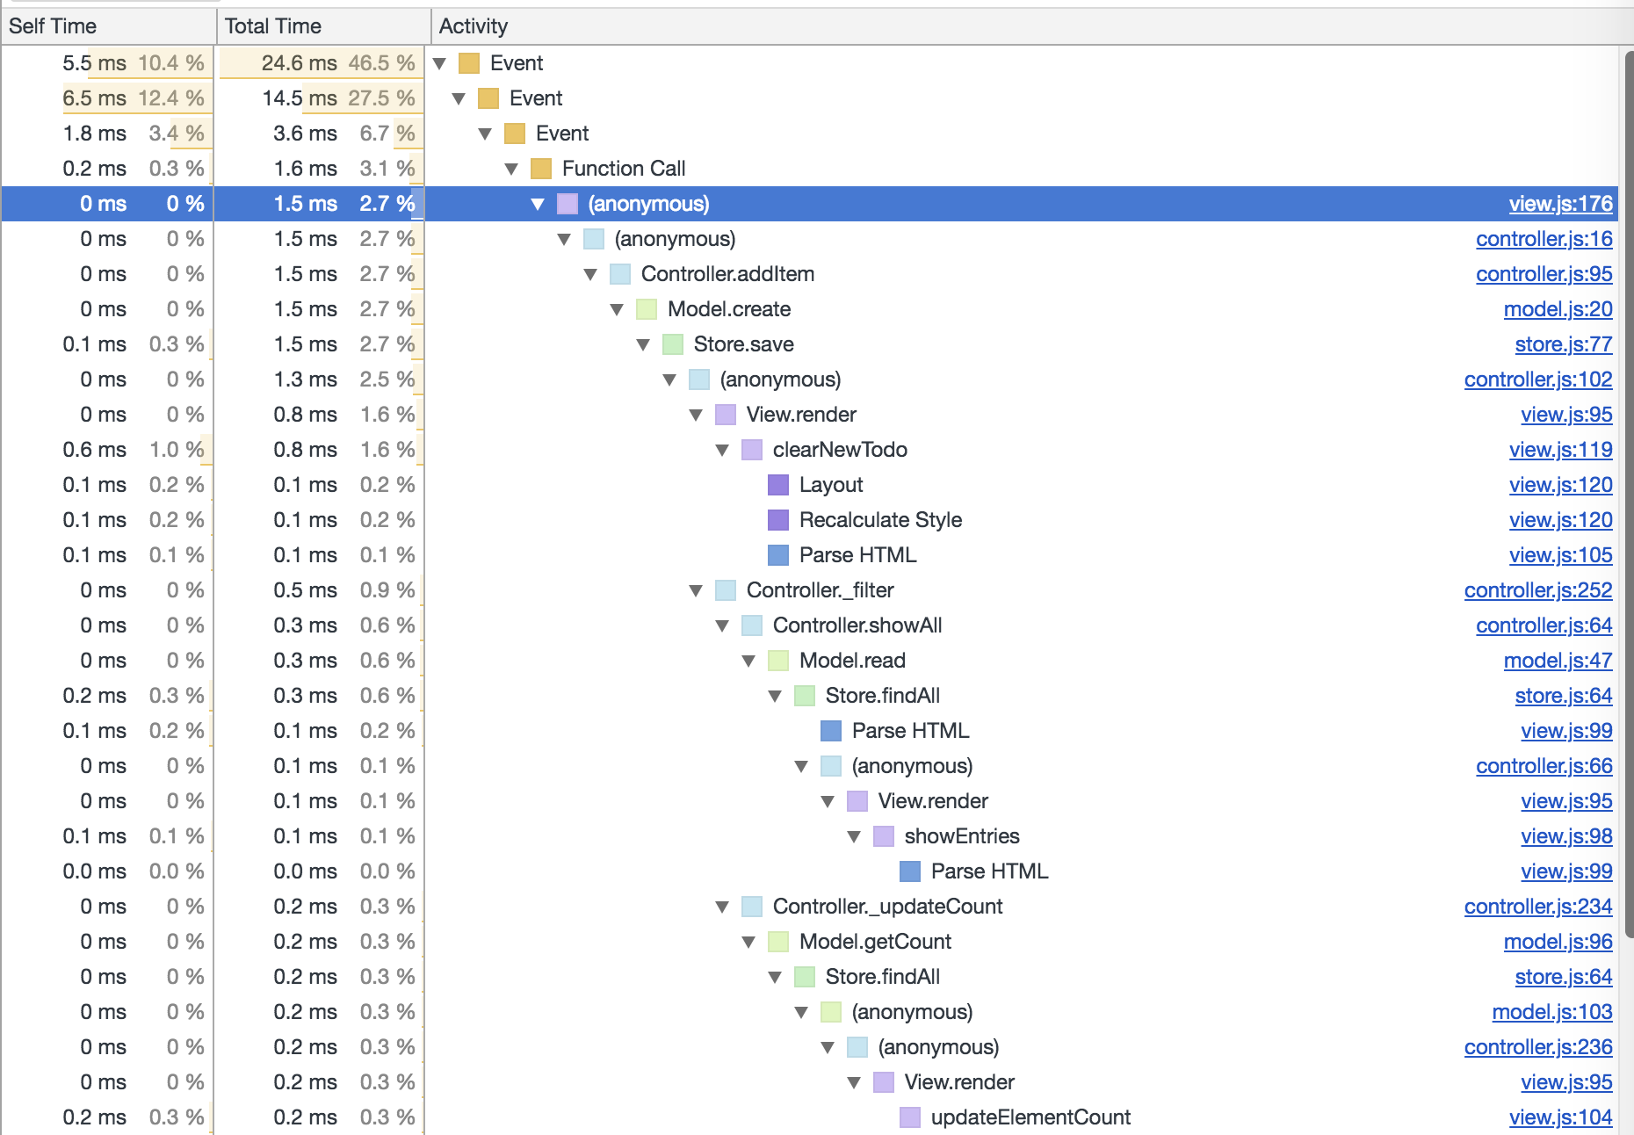

Here is the call hierarchy of adding a todo.

|  |  |  |
| --- | --- | --- |
|  | Our Todolist(ms) | Competitor(ms) |
| newTodo(<title>) | 24.6 | 323.8 |
| itemEdit(<item>) | 19 | 81.5 |
| itemEditCancel(<item>) | 20.1 | 24.8 |
| itemRemove(<item>) | 15.7 | 74.1 |
| itemToggle(<item>) | 19.7 | - |
| removeCompleted() | 4.8 | 102.3 |
| toggleAll(status) | 12.4 | - |
| showAll | 6.1 | - |
| showActive | 6.5 | - |
| showCompleted | 19.4 | - |

## 3. Features missing in our application

### 3.1 Undo

To undo a step, it takes about 46.4 ms. Inserting an item can’t be undone. A maximum of 10 steps can take back.

### 3.2 Lists

Organizes todos into lists. We can easily achieve the same behaviour by adding a list selection to the site. Clicking on a list, changes the label under which the data is stored in the session storage.

### 3.3 Postpone todos...

#### 3.3.1 … by Tomorrow

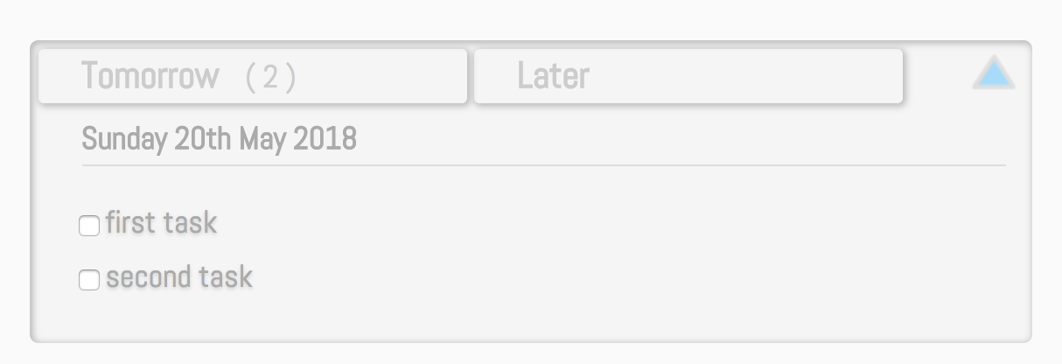

#### 3.3.2 … by Date

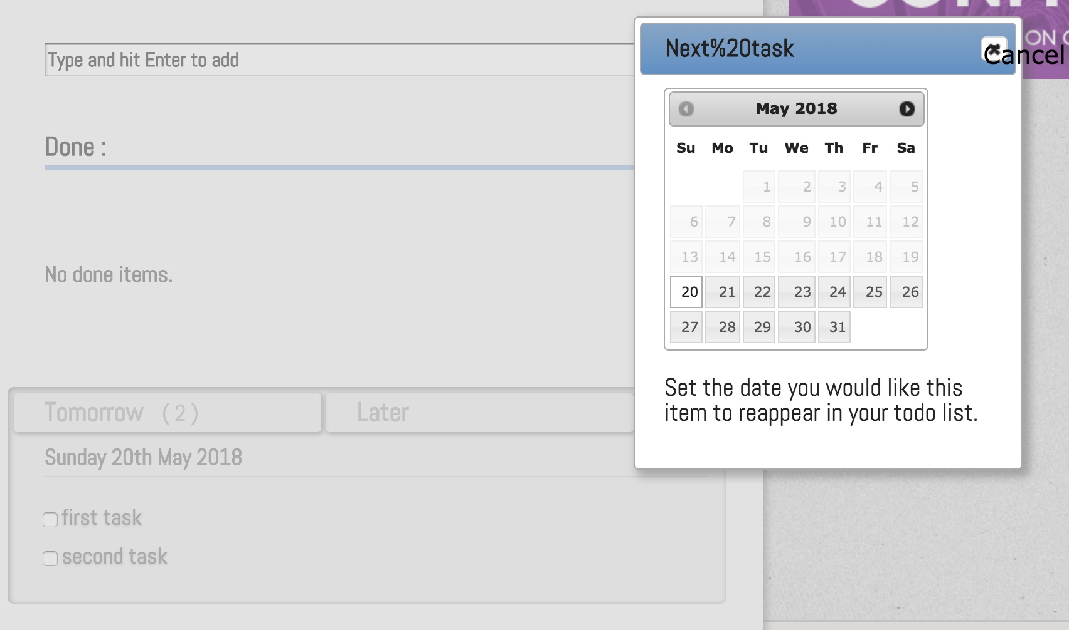

A date picker is opened when a task is drawn to the later field. The headline with a blank in it is not displayed correctly. Neither is the cancel button.

The date picker is mostly barrier-free, but not completely according to the rules of Bit-V2.

### 3.4 Synchronizing

It is not needed to store the data anywhere else than on the local machine. But for reasons, according to the help text of the site: “if you want more safety, or would like to share your lists across multiple devices”, it is possible to create an account and log into the account.

### 3.5 Opening a satellite window

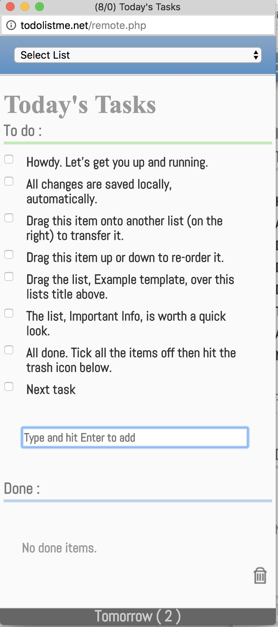  
To use the todo list on a second monitor or move the list around, it can be opened in a satellite window.

## 

## 4. Non-functional performance

The advertisement takes about

|  |  |  |
| --- | --- | --- |
| Size | Time(ms) | Item |
| 178 Byte | 149 | Script |
| 179 KB | 222 | Image |
| 280 KB | 146 | Image |
| 13.1 B | 138 | Font |
| 9.7 KB | 142 | Script |
| 129 B | 991 | Script |
| 67.4 B | 93 | Script |
| 6.9 B | 92 | Script |
| 26.1 B | 119 | text/html |
| 41.2 B | 490 | text/html |

The content loaded for the advertisement is a combination of images, fonts and textures. In the table are the total numbers for each part to load.